**Installing and Configuring MySQL and LDAP in WSO2 API Manager**

# **Steps To Configure MySQL as User Store in WSO2 API Manager**

1. Install MySQL 8.0

2. create Database with any name link user_store

3. Got to you API_HOME/dbscripts/ 

4. Edit MySQL’s file Copy all the Queries and Run in MySQL DB Client for user_store database.

5. Download JDBC Jar

<https://downloads.mysql.com/archives/c-j/>



6. Copy the mysql-connector-java-8.0.24.jar From Zip and Copy to

wso2am-3.2_2\wso2am-3.2.0\repository\components\lib

7.

Connection String: jdbc:mysql://localhost:3306/user_db?allowPublicKeyRetrieval=true&useSSL=false

**DriverName:** com.mysql.cj.jdbc.Driver

**Connection Name:** username of MySQL

**Connection Password:** password MySQL db.

# **Steps To Configure LDAP as User Store in WSO2 API Manager**

1. Download APACHE Directory Studio from Below Link

[**https://mirrors.estointernet.in/apache/[...]/ApacheDirectoryStudio-2.0.0.v20210213-M16-win32.win32.x86_64.exe**](https://mirrors.estointernet.in/apache/directory/studio/2.0.0.v20210213-M16/ApacheDirectoryStudio-2.0.0.v20210213-M16-win32.win32.x86_64.exe)

1. Install on Your System and Then Follow next Step.
2. Open Apache Directory Studio.
3. In the**LDAP Servers** tab found on the bottom left corner, click**New Server**.  
   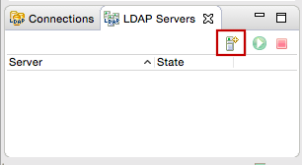
4. Select **LDAP server ApacheDS 2.0.0** and click **Finish**.  
   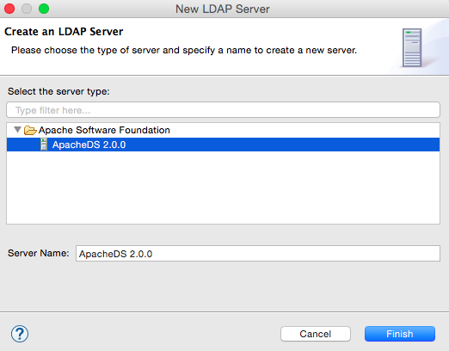
5. Right-click on the newly created server and click **Open Configuration**.   
   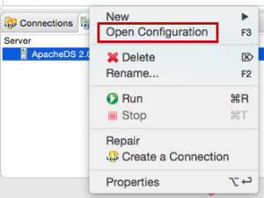
6. Port offset the LDAP and LDAP server ports by changing the LDAP port to 10390 and the LDAP server port to 10637. This ensures that the embedded LDAP server running in the prior installation of WSO2 IS does not conflict with the current installation.  
   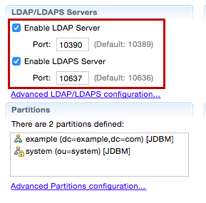
7. Right-click on the new server and click **Create a Connection**.   
   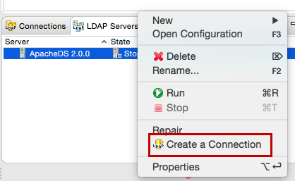
8. Right-click on the server and click **Run**to start the server.  
   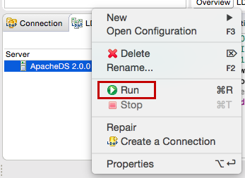

### Configuring the user store

1. Log in to the management console.
2. Click **Add** under **User Stores** on the **Main** tab and add a new secondary user store named "EMPLOYEES".   
   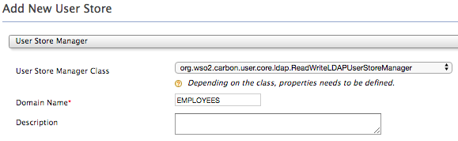
3. Configure the user store properties as follows.

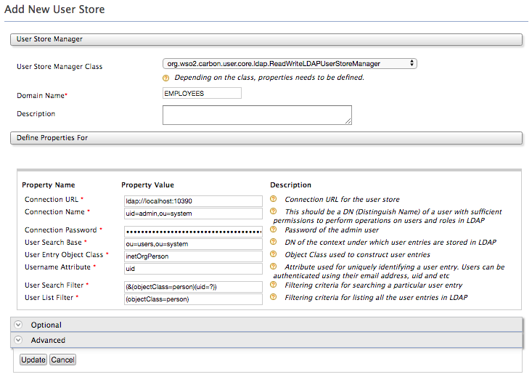

* 1. **Connection URL**- <ldap://localhost:10390>Right-click on the connection in ApacheDS and click **Open Configuration**. Since the LDAP server will run on your local machine, you can use the connection URL localhost:10390 according to the configured port.



* 1. **Connection Name** - uid=admin,ou=system  
     Right-click on the connection, click **Properties** and then click **Authentication.**The connection name is the username given as the **Bind DN or user** value.

The user is used to connect to the database and perform various operations. This user does not have to be an administrator in the user store or have an administrator role in the WSO2 product that you are using, but this user MUST have permissions to read the user list and users' attributes and to perform search operations on the user store. This value is the DN (Distinguish Name) attribute of the user.

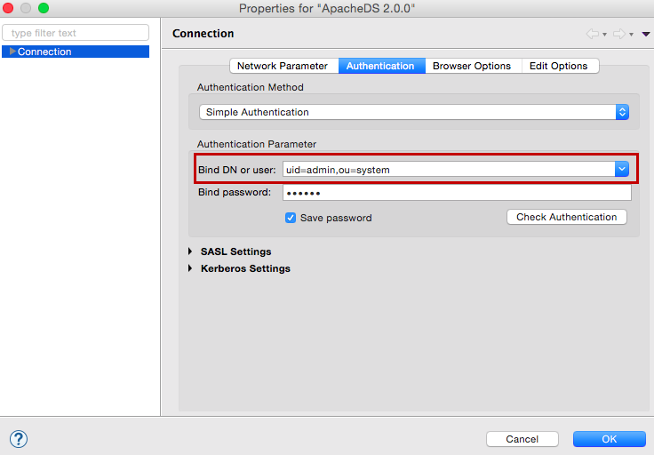

* 1. **Connection Password** - secret  
     This is the password for the user entered in the **Connection Name** field. Click on the admin user that is created by default to open up the related details.   
     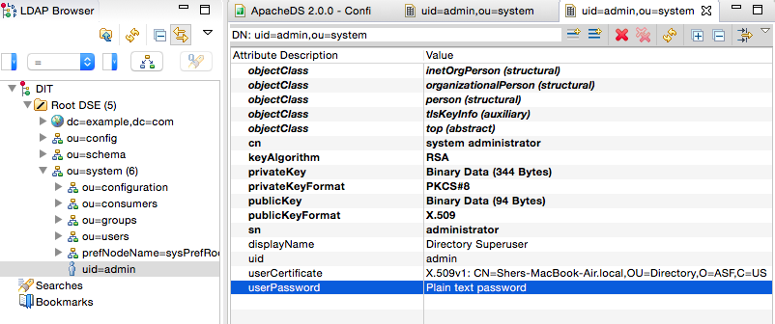

Double-click on **user password** and select the **Show Current Password Details** check box. The current password is displayed.   
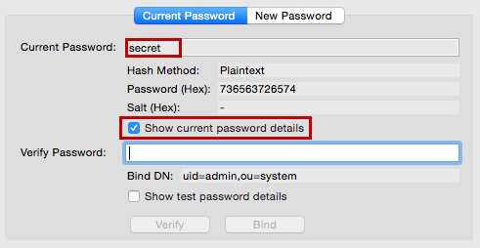

* 1. **User Search Base** - ou=users,ou=system  
     This is the DN of the context or object under which the user entries are stored in the user store. i.e. the "users" container. Double-click on **ou=users** on the LDAP Browser to view the DN value.   
     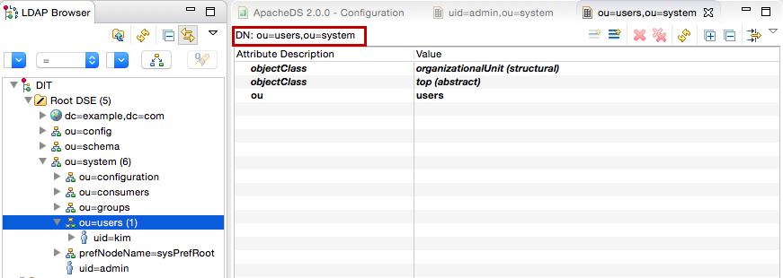
  2. **User Entry Object Class** - intetOrgPerson   
     To find a suitable User Entry Object Class, see the documentation on the directory service. For ApacheDS, see [Schema Elements](https://directory.apache.org/apacheds/basic-ug/2.3.1-adding-schema-elements.html).
  3. **Group Search Base** - ou=groups,ou=system  
     On the **Add New User Store** screen of the management console, expand the **Optional** tab and edit the **Group Search Base** field. This is the DN of the context under which the user entries are stored in the user store. Double-click on **ou=users** on the LDAP Browser of ApacheDS to view the DN value.

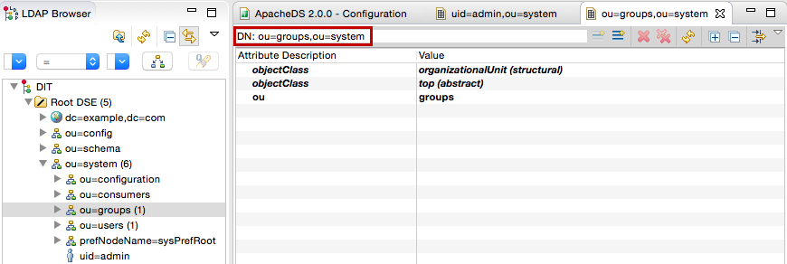

1. In order to reduce the complexity constraints of adding a username and password, disable the password quality check.
   1. Right-click on the connection in ApacheDS and click **Open Configuration**.
   2. Click on the **Password Policies** tab of the configuration window.
   3. Change the **Check Quality** field under the **Quality** section to **Disabled** and save the configuration.

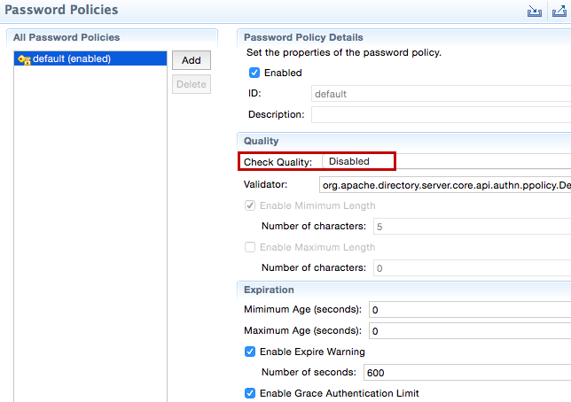

1. Click **Update** to save the configurations.